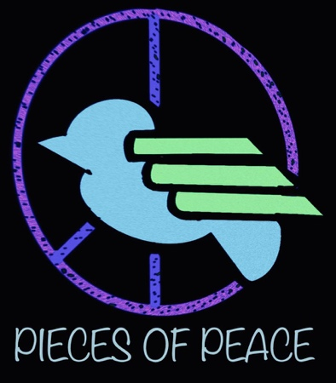

Frieden / Peace / Pace/ Paix/ Paz ……

In March 2021 our new film project
"Pieces of Peace" will start !

For this we will need: children, teenagers and adults from different countries.

Tell us what comes to your mind about peace! What dreams, what experiences and what wishes do you have? Make it something you can send to us!

We look forward to seeing your videos photos of a few seconds for a few minutes on music clips, film scenes, discussion, scenes from everyday life, on nature, dance scenes, texts. There is no limits to your creativity….

We are putting all the pieces of the puzzle for a piece together in order to unit them in International film project in 2022, as it should be both documentary and theatrical in nature. We will then seek and create a common thread for the design of the film from all the submissions.

You can record your scenes with good phones and good cameras. The better the sound, the higher the picture quality, the happier the audience will be later. (Full HD best 4 K25 or at least 4 K24). You can send all your ideas to PAKT e.V. via Web transfer.

It is important to obtain a signature from all the participants at the same time for the use and possibly also the short turning of film scenes, digital recordings and sound recordings. If we get a lot of submissions, we certainly won't be able to use all of them, but all submissions will help us in 2022 to find a common thread for a new International youth film project with the title: Pieces of Peace.

You can forward this invitation to your friends!

We look forward to your submissions!

Felicia Jübermann
PAKT e.V.
Schwarzwaldstrasse 221
79117 Freiburg
Mobil: 015222800566

